BUSINESS PROPOSAL
Chintan Parekh
DBM/294
University of Phoenix
July 19th, 2016

DATABASE MANAGEMENT BUSINESS PROPOSAL
Database management is a concern issue in present day business scenario. Every business corporation from small level to higher level need its important data to manage effectively and precisely. We are proposed to help you with this proposal that aims to help in managing the large amount of data records of your customers for the shipping order management system in the business. We all know that how much important is the data management for any organization or business. The proposed database management system helps your business to manage the orders and shipping details of every customers of the company. Implementing the SQL database management provides a comprehensive solution in managing the shipping orders, customer invoices of orders, credit status, customer details etc. DBMS implementation through SQL Server allows the managers to keep the data up-to-date when transformation marked through your business. You will be more comfortable implementing DBMS as a solution to you present business problem (Coronel, 2000).
Design of the Database that will solve the business problem
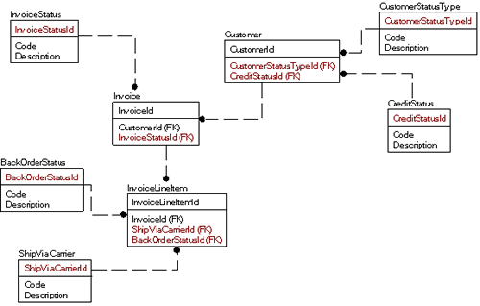
The given below tables are produced to keep the consumer and other related consumer invoices data that help you to utilize the DBMS like SQL Server platform. The tables shown has column with data of the customers and their orders details. The column data present with the specified primary and foreign keys to retrieve the required data of the customer and invoice order records.
Table 1: Customer Table
CustomerId (Primary key) | CustomerStatusTypeId (Foreign Key) | CreditStatusId (Foreign Key) | Name | Address
Integer | Integer | Integer | String | String

Table 2: CustomerStatusType Table
CustomerStatusTypeId (Primary Key) | Code | Description
Integer | Integer | String

Table 3: Invoice Table
InvoiceId (Primary) | CustomerId (Foreign) | InvoiceStatusId
Integer | Integer | Integer

Table 4: InvoiceStatus Table
InvoiceStatusId (Primary Key) | Code | Description
Integer | Integer | String

Table 5: InvoiceLineItem Table
InvoiceLineItemId (Primary) | InvoiceId (Foreign) | ShipViaCarrierId (Foreign) | BackOrderStatusId (Foreign) | ItemPrice | Quantity | ItemSoldId
Integer | Integer | Integer | Integer | Integer | Integer | Integer

Table 6: CreditStatus Table
CreditStatusTypeId (Primary) | Code | Description
Integer | Integer | String
Table 7: ShipViaCarrier Table
ShipViaCarrierId (Primary) | Code | Description
Integer | Integer | String

Table 8: BackOrderStatus Table
BackOrderStatusId (Primary) | Code | Description
Integer | Integer | String

We recommended that using SQL Server as database management package will be most suitable for the business activities like inventory management, customer order management, generating and keeping the simultaneous invoices of each customer. The database system will be implemented and executively manage the customer invoice records, shipping details, orders status etc. type of data through such system. You can easily manage the records in the tables as proposed in the database design for solving the management problem of your business for example, order, status, consumer details etc. The primary and secondary key association with each of the database table helps you to access the data of the requested data record easily and effectively (Morris, Peter, & Coronel, 2012).

Works Cited
Chopra, R. (2010). Database Management System (DBMS)A Practical Approach. S. Chand Publishing.
Connolly, T. M. (1996). Database Systems: A Practical Approach to Design, Implementation, and Management. Addison-Wesley Publishing Company.
Coronel, C. (2000). Database Systems: Design, Implementation, and Management. Course Technology.
Morris, S., P. R., & Coronel, C. (2012). Database Systems: Design, Implementation, and Management. Cengage Learning.

